**Association judgment error and policy decision with**

interaction time* concern; time*sum.product & time*judgment error

*y- axis = Sum of accepted RE policies*

*x- axis = judgment error = more is knowing less/ making more error*

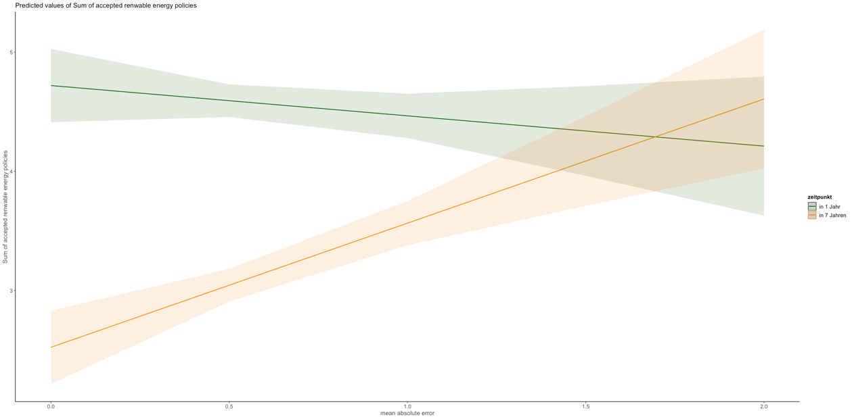

Here also with climate change

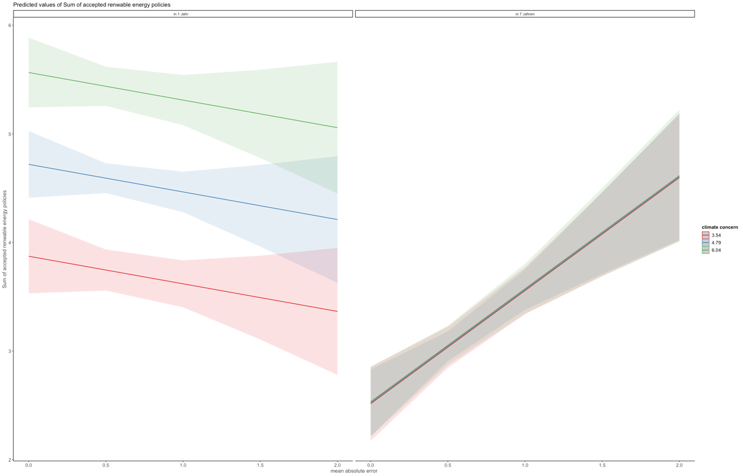

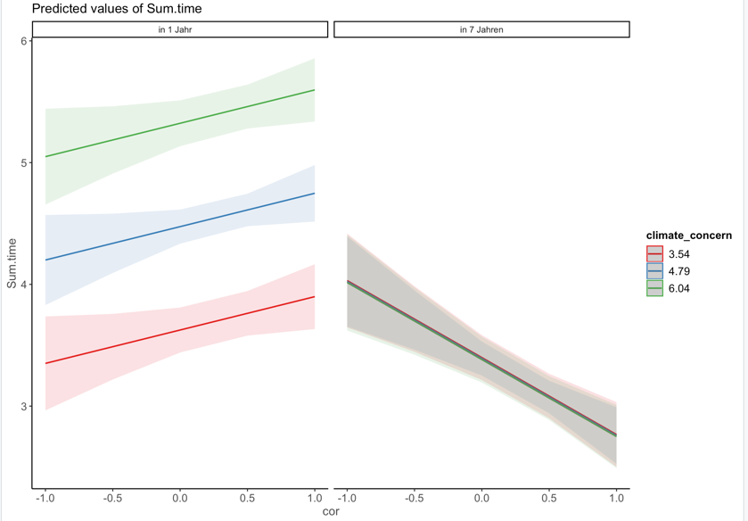

By the way also for decomposed error into cor (=relative understanding) and sd -> cor almost main effect (p=0.051) and significant interaction with time -> such that for immediate more knowledge = more policies

Sd so scale use neither main effect nor interaction with time -> so scale use no effect (because we also used this range that marghetis basically used as intervention to improve scale use)

**Association product choice with judgment error**

interaction energy level* concern; energy level*judgment error

*y- axis = proportion of pro-environmental decisions*

*x- axis = judgment error = more is knowing less/ making more error*

